

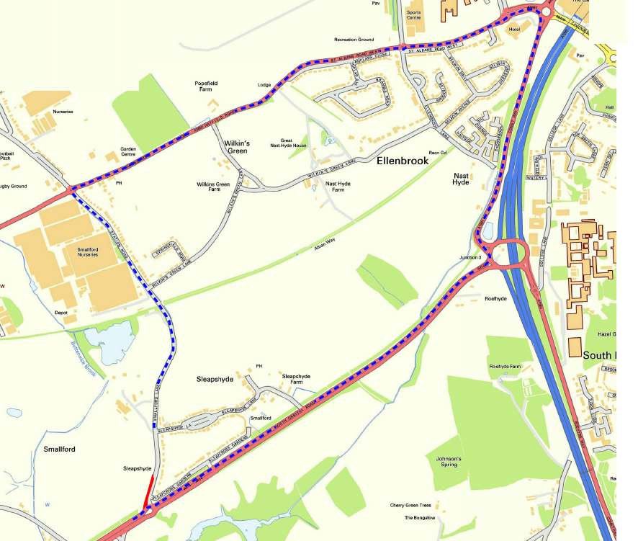
© Crown copyright and database rights 2021 Ordnance Survey 100019606
You are not permitted to copy, sub-licence, distribute or sell any of this data to third parties in any form. (This restriction may not apply to HCC and its licensed contractors, agents & partners.)
Smallford Road
Station Road
A1057 Hatfield Road
A1057 St Albans Road West
A1057 Comet Way
A414 North Orbital Road

Road Closure

Diversion

TEMPORARY TRAFFIC REGULATION ORDER

Smallford Lane, Smallford

