

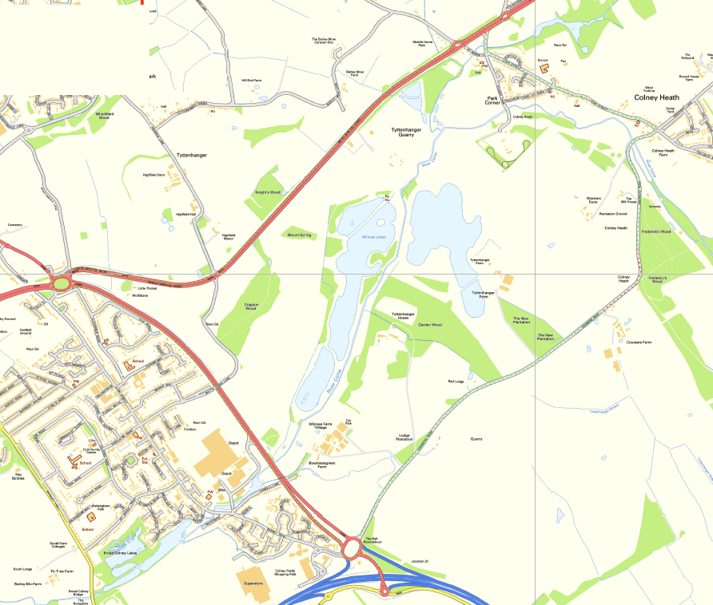
© Crown copyright and database rights 2019 Ordnance Survey 100019606
You are not permitted to copy, sub-licence, distribute or sell any of this data to third parties in any form. (This restriction may not apply to HCC and its licensed contractors, agents & partners.)
Coursers Road
High Street
A414 North Orbital Road
A1081 London Colney Bypass

Road Closure

Diversion

TEMPORARY TRAFFIC REGULATION ORDER

Coursers Road, Colney Heath

