ROESTOCK PARK HUT WORKING PARTY  OPTIONS FOR COMMUNITY USE  REPORT AND RECOMMENDATION  2 January 2025 |  |  |  |  | 
Purpose of the report
The purpose of this report is to provide the Council with an evaluation of the options, and recommendations, for the Roestock Park Hut in the context of the Council’s objectives to bring the building back into useful community use and delivering value for money. (Vision and Objectives, Appendix A).
Summary of the options considered
Option 1 |  | demolish the building and rebuild a multi-user facility operated by the Council
Option 2 |  | renovate the building for a multi-user facility operated by the Council
Option 3 |  | renovate and lease the building to a qualifying community group on a fully repairing, maintaining and insuring lease
Option 4 |  | lease the building to a qualifying community group for them to refurbish on a fully repairing, maintaining and insuring lease
Option 5 |  | demolish the building and lease the land to qualifying community group for them to replace with an appropriate facility
RECOMMENDATION
The working group recommends Council proceeds to
- engage with qualifying community groups on Option 4 – to lease for refurbishment by the tenant
- continue with the construction cost market pricing proposed by Brasier Freeth with the scope of work adjusted to test the estimated costs.
1 | BACKGROUND
1.1 | The Roestock Park Hut, formerly the Colney Heath Scout Group HQ, occupies part of Roestock Park in the Colney Heath village. The Parish Council lease Roestock Park from St Albans District Council. This head lease expires in 2092. The head lease stipulates the Park may not be used except “for the benefit of the local community by local scout groups football clubs and other similar organizations in connection with their respective normal activities and purposes” (referred to below as “qualifying community groups”).
1.2 | The land occupied by the building was leased to the Scout Association Trust Corporation as Trustee for the tenants (Colney Heath Scouts, Guides, and Brownies) in 1979 for a Scout hut on fully insuring, maintaining and repairing terms for 20 years. The building was constructed and occupied with resources provided by the tenants. A second land lease was granted in 1997 and expired in 2016.
1.3 | The building was added to the Council’s asset register in 2018. As no agreement for their continued occupation was reached, and the Guides having left the building, the Scouts were locked out in December 2019.  Council hardcopy records are stored in the building together with various items of the Scouts property.
1.4 | The building is insured for £808,500 which would be the cost for replacement for a total loss which would include demolition, reconstruction to current building regulations, associated legal and professional fees for design and project management, and expenses.
2 | CURRENT CONDITION
2.1 | The building comprises a hall measuring c.9.7m x by 13.2m, Leaders room, store room, kitchen, and male and female lavatories. The floor area is approximately 200m^{2.} There is a garage within the fenced compound. The condition of the building is commensurate with Scout huts visited by the working group.
2.2 | The building has suffered some deterioration since being unoccupied for 5 years.
3 | POTENTIAL OF THE CURRENT FACILITY
3.1 | With improvements it could continue to provide a facility for appropriate community use.  The remaining life of the building depends on the degree of improvements. The survey by Brasier Freeth in 2017 notes it appears to be structurally sound with solidly constructed walls. The supporting structure for the roof has signs of distortion and may need to be repaired at some point.  Brasier Freeth advised a 20 year loan term for a renovation based on the useful life of a new roof.
3.2 | The asbestos cement sheet roof covering has deteriorated and would need to be replaced in the medium term if it were not replaced as part on an initial renovation.
3.3 | Internally asbestos may be present in the lining to the ceiling of the main hall which will need to be repaired and possibly replaced.
3.4 | The thermal performance of the building is poor with uninsulated walls and minimal ceiling insulation.
3.5 | The garage roof is asbestos cement and blue asbestos is present which needs to be removed.
4 | CRITERIA FOR THE ASSESSMENT OF THE OPTIONS  Parish Council objectives  Community opinion  Regulatory  Local facilities and hirer demand  Operational  Parish Council use  Finance  Principal opportunities and risks
4.1 | Parish Council objectives  The Council’s objective is to bring the building back into useful community use. The facility has stood unused since December 2019.
4.2  4.2.1 | Community opinion  4ColneyHeath residents’ association conducted an opinion survey of their members (93% live in Colney Heath village) in 2021, a year after the Scouts were removed.  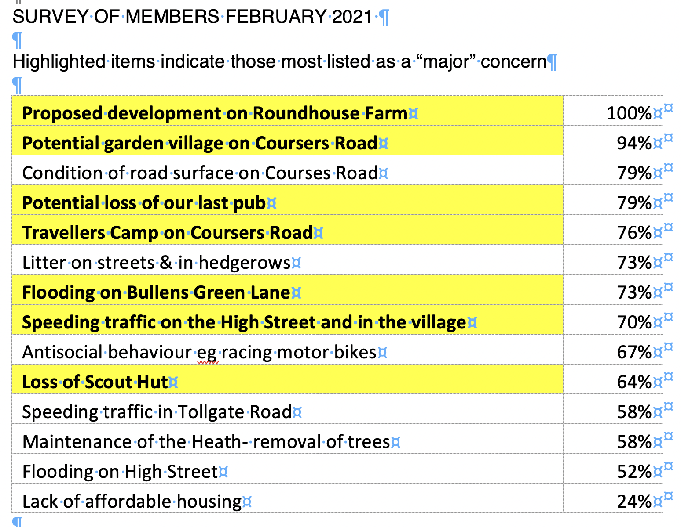
4.2.2 | Community opinion CHPC survey  A survey of residents in the Parish was conducted in 2022. This was before the re-organisation of the parish following the community governance review. The report by Eventure dated July 2022 noted 267 responses were received from an electorate of c.4,600 (5.8%). Regarding the Roestock Park Hut the responses were as follows.  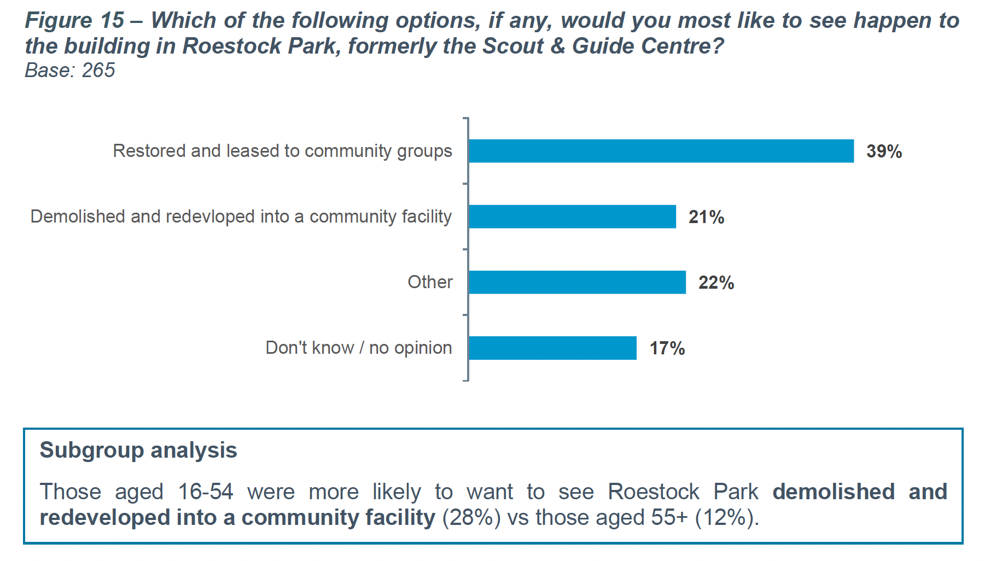  A further analysis of comments showed the following :  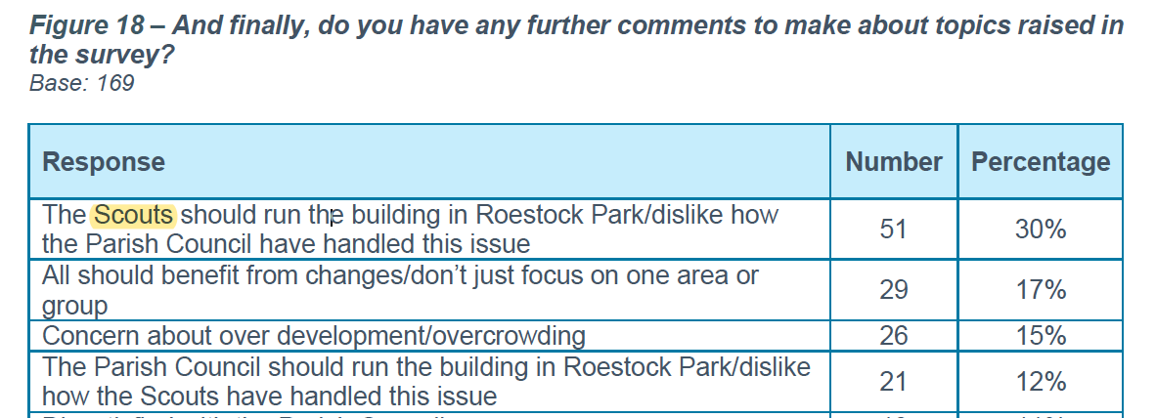  Regarding this survey  - responses were a small sample of the electorate  - responses were from the urban and rural areas of the parish of this survey, and  - no information was provided regarding the implications for the options to restore or develop and new building.
4.2.3 | Neither survey can be considered conclusive but concern by some residents, mainly in the village, remains at the removal of the Scouts from the building they constructed with their own funds
4.3 | Reputational consideration  Standing unused the building is incurring nugatory expenditure and reputational damage.
4.4  4.4.1 | Regulatory  Local Government Act 1972  Section 126 of the Local Government Act 1972 deals with the disposal of land by local authorities in England and Wales. Essentially, it sets the rules for how a local authority, like a parish or district council, can sell, lease, or otherwise dispose of land and buildings it owns.  A local authority typically needs the consent of the Secretary of State to dispose of land, especially if the disposal is at less than market value (below what the land is worth).  There are exceptions to the need for consent under section 126, especially when the disposal is for the benefit of the local community. The General Disposal Consent 2003 allows local authorities to sell or lease land for community or social purposes at less than market value, as long as:  - The difference between the market value and the disposal price does not exceed £2 million.  - The disposal promotes the economic, social, or environmental well-being of the area.  The term "disposal" can refer to selling the freehold, leasing the property, granting easements (rights of use), or otherwise transferring an interest in land.  The key consideration is whether the disposal serves the public benefit, which could allow for exceptions to strict market value rules.
4.4.2 | The head lease  The lease from St Albans District Council states the Park may not be used except “for the benefit of the local community by local scout groups football clubs and other similar organizations in connection with their respective normal activities and purposes”.  This may not necessarily preclude the use of the facility by additional types of users but permission may be required.
4.4.3 | Letting legislation  To lease to a tenant an Energy Performance Certificate minimum E rating is required. The building has an EPC E rating.  An exemption can be applied for (but not automatically granted) where all cost-effective improvements have been carried out, but this still does not result in an EPC rating of ‘E’ or higher.  From 2030, a commercial property cannot be let without a minimum EPC rating of ‘B’ for a new lease.  The estimates include insulating the roof and external walls which should to achieve a B rating.
4.5  4.5.1 | Community use  Users should be in accordance with the lease from the District Council. It is assumed that the Scouts or similar qualifying community group would be a prime user of the facility. Other users could include the Guides, community groups, and sports clubs.  Users could include sports groups or clubs and casual hires by residents e.g. family parties, and “commercial” hirers (defined as any hire that takes money from their users in excess of the hire charge), such as child daycare, yoga classes and exercise classes.
4.5.2 | The Scouts previously set out their use of the Scout Hut (see Appendix B).  It is assumed the use by a qualifying community group would be similar.
4.5.3 | For some of the options achieving the planned level of use by users would be required to provide income.
4.5.4 | The nature and extent of community use in an option may impact the potential financing – eg s106 monies and borrowing from the public works loan board.
4.6 | Local facilities and hirer demand
4.6.1 | Local facilities for hire in Colney Heath village include the Village Hall, the Primary School, St Marks Church hall, and the Football & Social Club. The other facility in the Parish is Charles Morris Hall in Tyttenhanger.
4.6.2 | The booking calendar published by the village hall shows the main hall is consistently booked as follows
 | day |  | Daytime school term times | Daytime school holidays |  | evening
 | Monday |  | 2 to 3 regular afternoons per month | 2 to 3 regular hires per month |  | 2 regulars per week
 | Tuesday |  | 1 regular to 3.30pm weekly |  |  | Scouts partial use
 | Wednesday |  | 1 regular to 3.30pm weekly |  |  | 1 regular per week
 | Thursday |  | 1 regular to 3.30pm weekly |  |  | Scouts partial use
 | Friday |  | 1 regular to 3.30pm weekly |  |  | 1 regular per week
 | Saturday |  | 1 regular morning weekly | 1 regular morning weekly
 | Sunday |  | 2 regulars am and pm weekly | 2 regulars am and pm weekly
The hall is hired on some Saturday afternoons and evenings for children’s and family parties.
The village hall receives a number of enquiries that cannot either be accommodated because, for example, the day/time requested is not available, or are considered unacceptable (eg teenager and large parties).

The hall receives several requests annually to host a pre-school service.

Excluding the pre-school, the village hall has regular hirers who book 12 sessions each week (a session being a morning, an afternoon or an evening.
4.6.3 | The Primary School is not available during weekdays daytimes during term times. It is unsuitable for regular evening hirers due to use for parents’ evenings.
4.6.4 | St Marks Church hall is generally more available but is not actively marketed by the Church.
4.6.4 | The Football and Social Club is hirer for a variety of social functions.
4.6.5 | Charles Morris Hall  The booking calendar published by Charles Morris Hall shows it has regular hirer booking day and evening times and Sunday evenings. Saturdays are reserved for parties.
4.6.6 | Based on local facilities there is a potential demand both regular and casual hirers but potential market demand has not been quantified. Another facility in the village might compete with the existing facilities if the quality, available times, and pricing, were advantageous.  For some options it is assumed that, with good marketing and booking processes, it would be possible to sell 8 sessions per week in addition to the use by a qualifying community group and the parish office.
4.7 | Operational  Managing and operating a Council facility (“community hall”) incurs a variety of expenses.  It also involves three main management functions – bookings, finance (mainly supplier payments and hire receipts), and facility maintenance. The amount of time required is proportionate to the level and variety of activities in the facility.  The most time demanding activity is bookings. If enquiries are not responded to very promptly potential hirers approach other venues. Time is also need for potential hirer venue inspections, checks and queries.  Council staff time need to be employed for this work or some/all of the functions can be outsourced to third parties.  Many community halls make a loss and have to be subsidised from the Council precept.  Where the facility is leased the operational cost is limited to periodic inspections and potentially building insurance.
4.8 | Parish Council use  Currently the parish office is in Highfield with archive records in the Hut. The lease on the Highfield office expires in April 2026 and an alternative will be required.  The options for a parish office have not been examined in detail but an option with the potential for the parish office should be considered as this would reduce rental outgoings.  If the parish office were included in the building this would limit daytime use to periods when the office is not used. The Parish Office was moved from the village hall due to “lack of quiet enjoyment” from the concurrent use by the pre-school.  The use of the building for Council meetings would reduce room hire costs.
4.9 | Finance
4.9.1 | The s.106 agreement monies from the Taylor Wimpey development states £34,000 for the “Scout hut and for no other purpose” and £16,000 for a new bus shelter in Hall Gardens. A balance of £10,000 may be available from the likely cost of £5,000 for a new bus shelter.
4.9.2 | The Council has allocated £30,000 for a Parish office in reserves.  The Council could use a further £60,000 of its reserves.  The evaluation of options assumes a cost of £6,000 per annum to restore the balance over 10 years.
4.9.3 | It is assumed the Council could borrow money from the Public Works Loan Board. The PWLB community benefit requirements indicate a parish office would qualify.
4.9.4 | The Parish Council rents the office at Highfield for a cost of c.£5,500 per annum and spends c£1,200 per annum on venue hire for meetings Council, committee, neighbourhood plan and working parties). A saving is assumed where the office and meeting space is included.
4.9.5 | The 2023/24 precept per elector in the Parish is £79.83 (electorate total 2,155).  This does not compare favourably with other Parish Councils.  The average precept per elector for all parish councils in Hertfordshire is £33.36.  The average precept per elector for parish councils in the range of 1,000 to 3,000 electors is £33.33 (see Appendix C).  An option that increased the precept would not be recommended unless there no other options available.
4.9.6 | The construction cost assessment of the options is based on an estimate provided by Brasier Freeth in October 2024. They aim to achieve +/- 10% estimating accuracy, but this could be +/-20%.  Whatever the estimate is, what matters is the price the construction market will offer. There are a number of variables that will influence the tender price.  At this stage the estimated costs provide a reasonable guide to the potential implications of each option.
4.9.7 | Operational costs have been estimated based on the experience from Charles Morris Hall and the village hall. The cost operational management time assumes a rate of 1.5 times the national minimum wage for all functions.
5  5.1 | OPTIONS  In terms of the Council’s objectives, community interest and reputational considerations, doing nothing is not an option.
5.2 | The working party has established the available options for consideration as follows:  Option 1 demolish and rebuild for multi-user use operated by the Council  Option 2 renovate for multi-user use operated by the Council  Option 3 renovate and lease to a qualifying community group or consortium of community groups  Option 4 lease the building to a qualifying community group to refurbish on a fully repairing, maintaining and insuring lease.  Option 5 demolish the building and lease the land to a qualifying community group for them to replace with an appropriate facility.  No other options have been identified.  If none of the options is proves viable, the last resort would be to demolish the building and incorporate the site into Roestock Park – the cost is estimated to be more than £60,000.
6 | OPTION 1  DEMOLISH AND REBUILD FOR MULTI-USER USE OPERATED  BY THE PARISH COUNCIL.
6.1 | A feasibility study for a new building would include a business case which would define the financial and operational viability of a facility based on the potential market need. This would generate a design brief with the type, number and size of facilities which could be different in layout and content to the current building.  In the absence of a design brief for a new building, the assessment of this option is based on replacing the existing building but to current standards of new-build construction.
6.2 | Parish Council objectives  This option aligns with the Council’s community use objective but obtaining consents, procurement and commissioning would extend the delay to providing a facility.
6.3 | Community opinion  Opinion will be subject to impact on the precept.
6.4 | Regulatory  The Parish Council has the power for this option. It would align with the terms of the head lease with the District Council but letting to “commercial” hirers may need permission.  The Scout hut at Fleetville had a pre-school “commercial” hirer that was included as a named party in the terms of the lease from the District Council. The pre-school hire there ceased some years ago as it was no longer viable.
6.5 | Community use  This option would meet the community use objective. The qualifying community group could have a licence to have exclusive use at defined times
6.6 | Hirer demand  After accounting for assumed use, the available sessions would be potentially up to 8 hire sessions per week. There may be sufficient demand but this has not been evaluated.
6.7 | Operational  Costs would be incurred including time for bookings, finance, housekeeping and facility maintenance.
6.8 | Parish Council use  This option could incorporate a parish office and provide a venue for Council meetings.
6.9 | Finance
Assumptions
The capital cost of the project would equal to the insurance value
The PWLB loan term would be 30 years
BUDGET ESTIMATE demolish and new build
Total project | £808,000
contributions to CAPEX
s.106 | £46,000
reserve for office | £30,000
available from general reserves | £60,000
Total | £136,000
PWLB sum | £672,000
PWLB annual cost | £47,132 | Appendix D
annual OPEX | £26,000 | Appendix D
general reserve recoup 10 years | £6,000
lettings income | (£15,560) | Appendix D
office rent saving | (£5,500)
Council meetings saving | (£1,200)
Increase in annual precept | £56,872

 | Based on 2025-26 level, the precept would be increased by c.30%.
6.10 | Principal opportunities and risks
6.10.1 | A new building may not cost as much as the insured value. This might reduce the amount of the loan.  A new building, purpose designed for current needs, would be an asset which would be of higher quality and have a longer useful life than renovating the existing building.  A more thermally efficient and new building would have reduced OPEX expenses compared with the refurbishment options.
6.10.2 | The main risks are  - cost and time overruns that many new build projects encounter  - the potential deficit arising from income being lower and costs being higher than expected.

7 | OPTION 2  RENOVATE FOR MULTI-USER USE OPERATED BY THE COUNCIL
7.1 | The building would be renovated with improved thermal performance EPC B and re-configured internally including forming a Parish Office.
7.2 | Parish Council objective  This option aligns with the Council’s objective.
7.3 | Community opinion  Opinion will be subject to impact on the precept.
7.4 | Regulatory  The Parish Council has the power for this option. It would align with the terms of the head lease with the District Council but letting to “commercial” hirers may need permission.
7.5 | Community use  This option would meet the community use objective. The qualifying community group could have a licence to have exclusive use of specific parts of the building at defined times
7.6 | Hirer demand  After accounting for assumed use, the available sessions would be potentially up to 8 hire sessions per week. There may be sufficient demand but this has not been evaluated.
7.7 | Operational  Costs would be incurred including time for bookings, finance, housekeeping and facility maintenance.
7.8 | Parish Council use  This option could incorporate a parish office and provide a venue for Council meetings.
7.9 | Finance
7.9.1 | Assumptions  - The capital cost of the project is estimated at c.£422,000. This assumes roof and wall insulation with overcladding to improve the EPC rating of the building. The alternative to change the heating system from gas to solar voltaic panels and battery storage, and to not insulate the walls, is about the same cost.  - Office rent at Highfield and room hire for meetings would be saved.
7.9.2 | Implication for the precept
project CAPEX estimate | £401,590 | Appendix E
Client contingency | £40,159
Total project | £441,749
contributions to CAPEX
s.106 | £46,000
reserve for office | £30,000
available from general reserves | £60,000
Total | £136,000
PWLB sum | £305,749
PWLB annual cost | £25,032 | Appendix F
annual OPEX | £32,000 | Appendix F
general reserve recoup 10 years | £6,000
lettings income | (£15,560) | Appendix F
office rent saving | (£5,500)
Council meetings saving | (£1,200)
Increase in annual precept | £40,772

 | Based on 2025-26 level, the precept would be increased by c.22%.
7.10 | Principal opportunities and risks
7.10.1 | The scope of the renovation works can be well defined limiting the risks associated with a new build project.
7.10.2 | The main risks are  - cost overruns associated with works to existing buildings  - the potential OPEX deficit arising from lower income and higher costs than expected .

8 | OPTION 3  RENOVATE AND LEASE ON A FULLY REPAIRING, MAINTAINING AND INSURING LEASE.
8.1 | The building would be renovated suitable for letting with improved thermal performance and re-configured internally. The building would be leased to the tenant on a fully maintaining, repairing, and insuring lease including maintenance of the enclosed grounds.  It could include a parish office.  Some of the non-statutory works could be done by the tenant on a volunteer basis.
8.2 | Parish Council objective  This option aligns with the Council’s objective.
8.3 | Community opinion  Opinion will be subject to impact on the precept.
8.4 | Regulatory  A market rental value of £70,000 per annum increasing a 4% per annum would equate to £2m over 20 years. The market value would be significantly less than this so a disposal under the Local Government Act would be exempted.  The Parish Council has the power for this option. It would align with the terms of the head lease with the District Council but letting to “commercial” hirers may need permission.
8.5 | Community use  This option would meet the community use objective
8.6 | Hirer demand  The tenant would be able to let limited number of casual hires to generate income.
8.7 | Operational  There would be limited costs and management time for the Parish Council.
8.8 | Parish Council use  This option could provide a parish office and venue Council meetings at no cost.
8.9 | Finance
Assumptions
The loan term would be 20 years
The tenant’s costs for “DIY” would be c.£7,000, assumed to be accepted for a peppercorn rent with the benefit of casual lettings income to assist in the FRM&I requirement.
project CAPEX estimate | £315,892 | Appendix G
Client contingency | £31,589
Total project | £347,482
contributions to CAPEX
s.106 | £46,000
reserve for office | £30,000
available from general reserves | £60,000
Total | £136,000
PWLB sum | £211,482
PWLB annual cost | £17,358 | Appendix H
annual OPEX | £1,728 | Appendix H
general reserve recoup 10 years | £6,000
lettings income | £100 | Assume “peppercorn”
office rent saving | (£5,500)
Council meetings saving | (£1,200)
Increase in annual precept | £18,486

 | Based on 2025-26 level, the precept would be increased by c.10%.
8.10 | Principal opportunities and risks
8.10.1 | The opportunity is the reduction in additional precept and minimal Council lease management required.
8.10.2 | The main risk is the tenant’s ability to meet their lease obligations.

9 | OPTION 4  LEASE THE BUILDING TO A QUALIFYING COMMUNITY GROUP TO REFURBISH ON A FULLY REPAIRING, MAINTAINING AND INSURING LEASE
9.1 | The building would be leased to the tenant who would be responsible for the initial renovation work necessary for initial occupation. The majority of the initial works would be carried out under a formal main contract with some appropriate works by the tenant with volunteers  The tenant would raise funds for improvements as necessary post occupation.  The parish office would not form part of the project but could be located on the site as a separate project.
9.2 | Parish Council objective  This option aligns with the Council’s objective.
9.3 | Community opinion  Opinion will be subject to impact on the precept.
9.4 | Regulatory  The Parish Council’s power for this option is subject to confirmation. It would align with the terms of the head lease with the District Council.
9.5 | Community use  This option would meet the community use objective but assumed not to qualify for PWLB funding.
9.6 | Hirer demand  The tenant would be encouraged to let the available sessions to supplement their income.
9.7 | Operational  Limited management time would be required annual inspections and land lease payments.
9.8 | Parish Council use  This option could provide a venue for a parish office and for Council meetings.
9.9 | Finance
Assumptions
s.106 monies contribution to the initial renovation works £46,000
Some of the works that could be done “DIY” by volunteer labour are estimated for materials only.
PWLB would not qualify.

In relation to the saving of office rent and for meetings the Parish Council could consider a grant to the tenant equal to the office reserve. The annual saving would be in the order of £6,700 per annum to four and half years of saving.

In order to be viable the party taking on the project would need to achieve funding in the order of £100,000 for pre-occupation works.

project CAPEX main contractor | £122,530 | Appendix J
contingency | £12,253
tenant “DIY” works | £11,200
 | £145,983
contributions to CAPEX
s.106 | £46,000
Parish council grant | £30,000 | Office fund
Grants/tenant supplied funds | £69,983

The tenant would then need to fund the deferred works post occupation totalling around £150,000 over an extended period.
9.10 | Principal opportunities and risks
9.10.1 | The opportunity is essentially no increase in the precept and minimal management of the lease.
9.10.2 | The main risks are the tenant’s ability to secure the funding required, to deliver the renovation, and to meet their lease obligations.

9 | OPTION 5  DEMOLISH THE BUILDING AND LEASE THE LAND TO A LOCAL COMMUNITY GROUP FOR THEM TO REPLACE WITH AN APPROPRIATE FACILITY.
9.1 | This option would require guarantees from the community group that they would execute the project. The substantial cost of a new building would require fund raising.
9.2 | Parish Council objective  Given the need for guarantees and an uncertain outcome, and the time to deliver, this option would not align with the Council’s objective.
9.3 | Community opinion  May be supported subject to the proposal.
9.4 | Regulatory  The Parish Council has the power for this option. It could align with the terms of the head lease with the District Council subject to the parties involved.
9.5 | Community use  This option would meet the community use objective
9.6 | Interest in this option  No party has yet come forward proposing this approach.
9.7 | Operational  Limited costs would be required for land lease management.
9.8 | Parish office  This option could incorporate a parish office and provide a venue for Council meetings.
9.9 | Finance
 | The Parish Council would need to fund the cost of demolition and site clearance including asbestos removal estimated to be more than £60,000.
9.10 | Principal opportunities and risks
9.10.1 | The opportunity would be a new building.
9.10.2 | The risks are that the tenant may not deliver the project or fail to meet their lease obligations.

10 | SUMMARY OF EVALUATION OF OPTIONS
10.1 | The table below summarises the options in relation to the assessment criteria  with a simple unweighted score of 1 to 5 | 1 | Scores very poorly
 |  | 2 | Scores poorly
 |  | 3 | Scores broadly neutral
 |  | 4 | Scores well
 |  | 5 | Scores very well

CRITERIA | 1 |  | 2 |  | 3 |  | 4 |  | 5
 | Operate new build |  | Renovate and operate |  | Removate and lease |  | Tenant to renovate |  | Demolish and lease land
CHPC objective - early delivery | 2 |  | 5 |  | 4 |  | 4 |  | 2
Alignment with community opinion
Regulatory compliance | 4 |  | 4 |  | 4 |  | 4 |  | 4
Community Use | 5 |  | 5 |  | 4 |  | 3 |  | 2
Hirer demand | 4 |  | 4 |  | 4 |  | 5 |  | 1
Operational complexity | 2 |  | 2 |  | 4 |  | 4 |  | 4
Parish Council use - meetings | 4 |  | 4 |  | 3 |  | 4 |  | 2
Parish Council use - office | 4 |  | 4 |  | 4 |  | 4 |  | 2
Impact on precept | 1 |  | 1 |  | 1 |  | 4
Opportunity | 4 |  | 4 |  | 4 |  | 4 |  | 2
Risk | 2 |  | 3 |  | 3 |  | 2 |  | 1

11 | CONCLUSION
11.1 | Taking ownership of the building from the Scouts resulted in their problem of an ageing building in need of improvement became the Parish Council’s problem. The solution has to be achieved within the regulatory constraints imposed on Local Government.
11.2 | Based on the cost estimate only option 4 - lease to a qualifying community group to refurbish on a FMR&I lease – avoids an increase in the precept. The estimate may be lower or higher than building contractors may charge.  It is for this reason that trade contractors be invited to provide prices so that the options can be more definitively assessed.
11.3 | Consulting the community on the options will be important to support the decision the Council has to make.

APPENDIX A

VISION AND STRATEGIC PLAN FOR 23/24
OUR VISION
Our vision is for the Colney Heath Parish Council to be a “Good Council”
which means :
- to be representative of and actively involve all parts of our community;
- to work positively and closely with voluntary and community groups, articulating community needs through effective communication and plans for the parish;
- to be effectively and properly managed;
- to work in partnership with other local authorities and agencies to get the best deal in service delivery for the local community.

Referring to best practice examples we aim to develop the Council’s operational style in line with the culture we wish to create
which means being :
- straightforward, open and transparent
- positive, approachable and (except when essential) informal
INITIAL OBJECTIVES
We have been elected for 4 years until the next election in May 2027.
Once we have engaged with our community through surveys, community conferences, and statements of intent, our initial objectives and our plan of action will be refined and developed.

We aim to complete the initial consultation by November 2023 so that the budget for 2024/25 can be set.
PLAN OF ACTION FOR 2023/24
1 | Initial Objective : oppose inappropriate development proposals
 | The Planning Working Party will be developed to provide time, energy and skills to support the Council in all planning matters. This will include planning applications and subsequent submissions for reserved matters, planning inquiries for appeals, and review of the District Council’s emerging Local Plan.
2 | Initial Objective : Neighbourhood Plan
 | The Neighbourhood Plan Steering Group will be concerned with formulation of a long-term vision for the developments required to meet the needs of our community. The group will be enhanced with volunteers providing time, energy and skills to develop the plan for the parish. The aim will be to have an approved plan before the election to be held in May 2027.
3 | Initial Objective : Enhance our environment
 | The Environment Working Party will identify tasks and projects intended to protect and enhance our environment. It is envisaged that volunteers will play an important role in this work.
4 | Initial Objective : Understand residents’ issues
The Community Organisations Liaison Group will connect with the community groups (institutions, organisations, and clubs) and local businesses in the Parish. This will form the basis of surveys to establish local needs and concerns, and inputs to the development of the Council’s strategy for meeting these needs.

This group will arrange a conference with representatives of community groups to establish their plans for the current and next financial years to inform the Council’s annual plan and budget, and a further meeting to review progress.
5 | Initial Objective : inform residents
The Communications Working Party will prepare a bi-monthly newsletter for distribution in hardcopy to all households in the parish. This will include information about activities by the Council and community groups.

The working party will develop a means to encourage residents to access communications from the Council in digital form and to promote the means for the digitally excluded to gain access.

Together with the Community Organisations Liaison Group the working party group will collate events planned by the community for input to a central calendar of events available to all digitally connected residents.
6 | Initial Objective : Support community groups
Based on the needs and ambitions defined by local community groups, the Council will develop a plan for the allocation of resources to assist their delivery of services to the community.

The Council will budget to provide grants to support this work, subject to agreement by the community on the effect on the precept.
7 | Initial Objective : Resolve legacy issues
The Council will use reasonable endeavours to
- resolve the outstanding leases by negotiation, without incurring advisors costs, including those for the Charles Morris Hall and the Football and Social Club
- bring the Roestock Park Hut back into useful community use and
- provide suitable premises for the Parish office.
8 | Initial Objective : Simplify bureaucracy
 | The Council will examine its administration practices and reduce and simplify these where possible.
9 | Initial Objective : Provide value for money
 | The precept for Band D is double the average for Parish Councils. The Council will review its expenditure including expenditure for services delivered in similar Parish Councils to establish the appropriate rate and budget for 2024/25.

APPENDIX B
SCOUTS USE REGIME OF THE HUT.

- Cubs, Beavers and Scouts meet on three separate weekday evenings not co-inciding with committee meetings which are held on the other two weekdays.
- On Saturdays football gear for the Cubs matches is collected and returned.
- Equipment for camping is made available for pick up on Mondays or Tuesday or Wednesdays and then collected on Fridays or Saturdays and returned on Sundays, much of this equipment is placed in the hall to dry out after wet weather – this can take several days .
- Committee meetings are held on Mondays or Tuesdays.

APPENDIX C
PRECEPT DATA

Parish Councils with electorate between 1,000 and 3,000

 | Precept | Electors | £/elector
Colney Heath | £172,025.00 | 2,155 | £79.83
Sarratt | £106,213.00 | 1494 | £71.09
Ashwell | £94,923.83 | 1582 | £60.00
Kimpton | £82,425.00 | 1788 | £46.10
Pirton | £54,199.63 | 1,214 | £44.65
Datchworth | £52,971.00 | 1233 | £42.96
Chipperfield | £58,254.62 | 1408 | £41.37
Hertford Heath | £74,970.00 | 1819 | £41.21
Codicote | £109,114.00 | 2673 | £40.82
Braughing | £42,817.00 | 1062 | £40.32
Flamstead | £39,247.00 | 1061 | £36.99
Stanstead Abbotts | £53,000.00 | 1464 | £36.20
Ickleford | £58,000.00 | 1660 | £34.94
Markyate | £85,625.04 | 2545 | £33.64
Offley & Cockernhoe | £40,780.35 | 1230 | £33.15
Shenley | £97,156.00 | 3235 | £30.03
Thundridge | £33,850.00 | 1216 | £27.84
Much Hadham | £43,000.00 | 1592 | £27.01
Tewin | £35,000.00 | 1296 | £27.01
Woolmer Green | £28,836.00 | 1151 | £25.05
Tring Rural | £30,200.00 | 1211 | £24.94
Walkern | £29,237.00 | 1205 | £24.26
Watton-at-Stone | £42,545.00 | 1995 | £21.33
Nettleden & Potten End | £23,995.00 | 1215 | £19.75
St Ippolyts | £26,731.22 | 1,588 | £16.83
Northchurch | £38,330.92 | 2346 | £16.34
Nash Mills | £37,759.15 | 2385 | £15.83
Wigginton | £18,000.00 | 1190 | £15.13
Stanstead St Margarets | £16,000.00 | 1238 | £12.92
Great Amwell | £21,670.00 | 1761 | £12.31
average |  |  | £33.33

APPENDIX D
OPTION 1 DATA

PWLB repayment

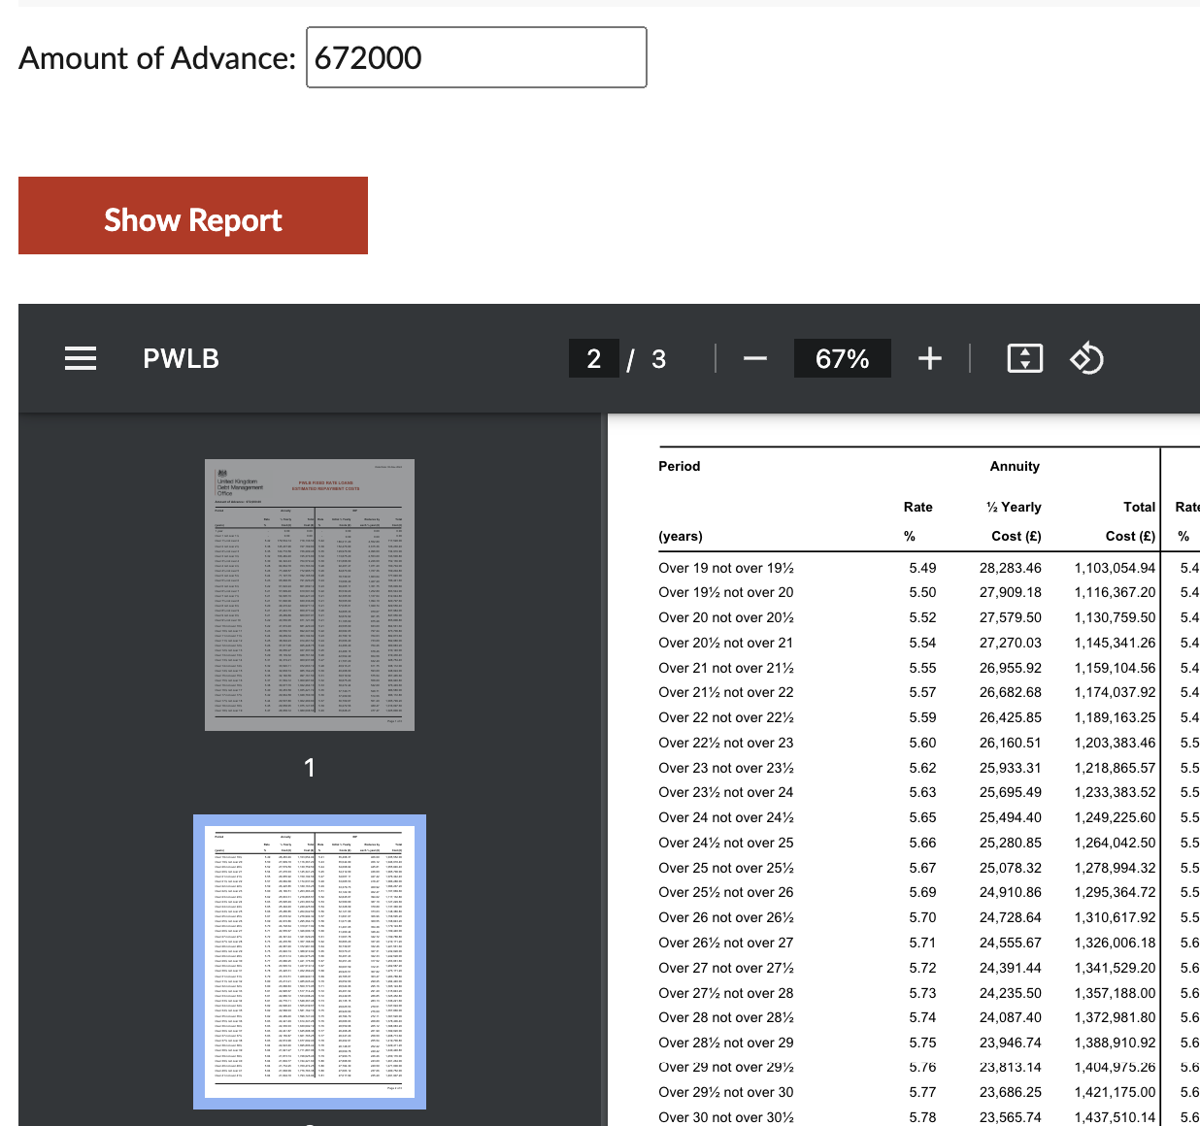

OPEX |  |  | £ per annum
Utilities |  | Gas & Electricity | £500
 |  | Water | £300
 |  | Council Tax | £2,000
Cleaning |  | Cleaning & sanitary materials | £500
Maintenance |  | Routinue annual maintenance | £500
 |  | repairs and replacement | £1,000
 |  | quinquennial fixed wiring test | £100
 |  | hard and soft external areas | £2,000
Assurance |  | PAT testing | £100
 |  | Fire alarm&appliances testing | £450
 |  | boiler maintenance | £200
 |  | Insurance | £1,600
Services |  | PRS licence | £200
 |  | WiFi | £250
 |  |  | £9,700
Staff
housekeeper/cleaner |  |  | £6,480
bookings & promotion |  |  | £3,456
finance |  |  | £3,456
facility management |  |  | £3,456
 |  |  | £16,848
TOTAL OPEX |  |  | £26,548

STAFF COSTS
 | hrs/month | assumed £/hr | annual cost |  | notes
housekeeper | 30 | £18 | £6,480 |  | 2 hrs/visit, 3 visits per week, plus 4 casuals per month
bookings & promotion | 16 | £18 | £3,456 |  | 4 hours per week
finance | 16 | £18 | £3,456 |  | monthly invoicing, payments, banking, accounts
facilties management | 16 | £18 | £3,456 |  | 4 hours per week
 | 78 |  | £16,848

POTENTIAL AVAILABLILITY FOR HIRES
Annually the times that would be available for use of the facility by the qualifying community group (QCG) Scouts and other regular/casual hirers

 | Mon | Tue | Wed | Thu | Fri | Sat | Sun
Morning | QCG | QCG | √ | CHPC | CHPC | QCG | √
Afternoon | QCG | QCG | √ | √ | √ | √ | QCG
Evening | QCG | QCG | √ | CHPC | QCG | √ | QCG

POTENTIAL LETTING INCOME

 | number/week | number annual | rate | annual
QCG |  |  |  | £5,000
regular & casual | 8 |  | 25 | £9,600
casual parties |  | 12 | 80 | £960
 |  |  |  | £15,560

APPENDIX E
OPTION 2 CAPEX

BUDGET ESTIMATE OPTION 2
RENOVATE AND LET TO USERS
External landscape
General tidy up of the site - cut grass, clear moss from paths, repair fencing |  | £2,000
New fence to separate PROW within NW and SW boundary, height and style similar to exisiting. Total length approx 90m. |  | £6,300
Building envelope works
remove moss growth, clear gutters and seal holes to roof (note asbestos constraints)
clear and overhaul rainwater goods (note asbestos constraints)
rectify displace bolt fixings to the roof sheets and caps missing
perspex glazing changed for double glass glazing. |  | £2,100
Safe Access onto roof to undrtake repairs
repair damaged concrete post adjacent to entrance door. |  | £200
correct the roof verges that are slightly misaligned and displaced.
Provide improved ventilation to ceiling void by installation of vents within the cladding to the gable end
Provide gratings to gullies to prevent future blockages.
Complete external redecoration of previously painted surfaces |  | £6,000
Fully insulate the roof void to current standards
Insulate and overclad the external walls. |  | £40,000
Security grilles fixed to windows |  | £10,000
Gas / heating system
Test gas boiler and heating system Itemize all items required |  | £600
From test results provide budget for required rectification works |  | £1,000
fix displaced radiators or pipes are re-fixed. |  | £1,000
Form cupboard around boiler |  | £500
Provide thermostatic radiator valves to radiators throughout the property. |  | £1,500
Paint radiators |  | £600
remove gas boiler and replace with raidiant heaters/panel heaters
Electrical system
Test all electrical systems and installations including fixed wiring installation - |  | £1,000
From test results provide budget for required rectification works |  | £5,000
Test and repair emergency lighting system |  | £5,000
Replace cracked fused spur in female WC |  | £150
lockable housing to electricity and gas intakes and meters |  | £500
mechanical extraction to WC’s and kitchen |  | £2,000
improve lighting levels in access corridor |  | £750
New lighting in the hall |  | £15,000
Install solar PV panels with battery storage
Plumbing, Water services and drainage system
Test water supply system |  | £1,500
Undertake a CCTV Drainage Survey |  | £1,800
Check for soakaway or discharge of the surface water to the mains drainage.
From testing itemize and provide estimate for required rectification works
make internal and external main stop cocks readily accessible and in good conditon |  | £1,200
 |  | £0
Replace cover to drainage inspection chamber. |  | £500
Install air admittance valve to soil and vent pipe which terminates in roof void. |  | £300
Replace cracked urinal |  | £300
Provide hot water to female and male WCs |  | £1,000
Fire and life safety system
Undertake Fire Risk assessment |  | £1,200
From assessment itemize recommendations and provide budget including as necessary the following |  | £0
central mains powered fire alarm |  | £5,000
emergency lighting and fire escape signage
replacement of internal doors with fire rated doors, smoke and intumescent seals and closers. |  | £1,000
Conduct Access Audit
Access audit to consider necessity for wheelchair access and WC for potential users. |  | £1,800
Install Accessible toilet |  | £20,000
Internal Fabric and Finishes
Fill cracks to the ceiling within the female WC corresponding with diagonal cracking to the adjoining wall.
Fill cracks adjacent to the wall hatch between the Leader’s Room and the hall.
Redecorate internally |  | £30,000
Remove and replace fibre board ceiling panels (insulation covered in 2.10)
ASBESTOS
Update the register of asbestos |  | £2,000
Prepare management plan of Asbestos containing materials (ACM).
Remove the displaced fibre board panels to the ceiling and replace with plasterboard or similar. With reference to the Asbestos Survey, the paper lining to fibre boarding contains asbestos. Note Prior to remedial works being undertaken any asbestos containing materials need to be handled and disposed of safely and in accordance with current legislation.
Garage
Demolish garage |  | £5,000
remove and dispose asbestos |  | £3,000
SUBTOTAL WORKS excluding roof replacement option
remove roof and replace with insulated profiled metal sheeting |  | £70,000
Compliance matters
CDM /Building Safety Act |  | £1,500
Refurbishment & Demolition pre -constuction survey |  | £750
Building Regulations Application & admin |  | £2,200
Planning Application |  | £1,800
SUBTOTAL WORKS including roof replacement option |  | £253,050
Contractor's Preliminaries |  | £37,958
SUBTOTAL including prelims |  | £291,008
Professional fees and expenses |  | £43,651
VAT |  | £66,932
TOTAL PROJECT ESTIMATE excluding Client held contingency |  | £401,590

APPENDIX F
OPTION 2 DATA

PWLB repayment

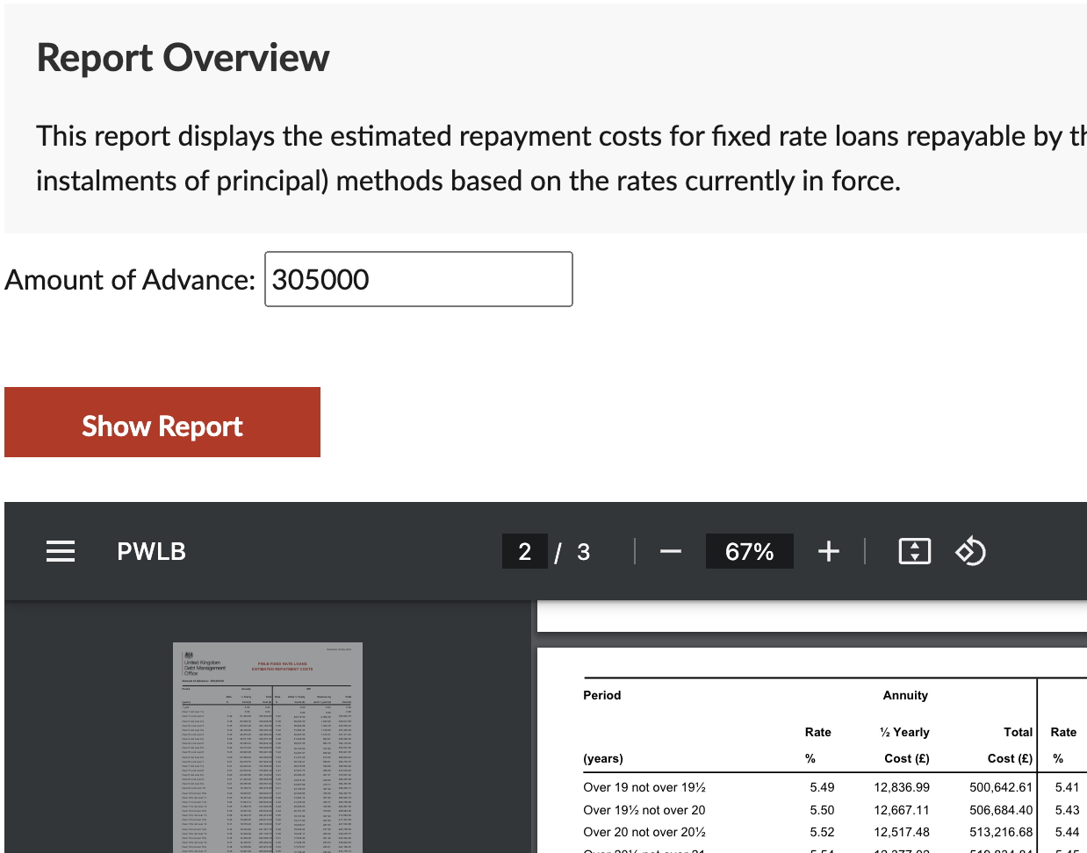

POTENTIAL AVAILABLILITY FOR HIRES AS OPTION 1
POTENTIAL LETTING INCOME AS OPTION 1

OPEX |  |  | £ per annum
Utilities |  | Gas & Electricity | £4,000
 |  | Water | £300
 |  | Council Tax | £2,000
Cleaning |  | Cleaning & sanitary materials | £500
Maintenance |  | Routinue annual maintenance | £1,000
 |  | repairs and replacement | £2,000
 |  | quinquennial fixed wiring test | £100
 |  | hard and soft external areas | £2,000
Assurance |  | PAT testing | £100
 |  | Fire alarm&appliances testing | £450
 |  | boiler maintenance | £200
 |  | Insurance | £1,600
Sevices |  | PRS licence | £200
 |  | WiFi | £250
 |  |  | £14,700
Staff
housekeeper/cleaner |  |  | £6,480
bookings & promotion |  |  | £3,456
finance |  |  | £3,456
facility management |  |  | £3,456
 |  |  | £16,848
TOTAL OPEX |  |  | £31,548

APPENDIX G
OPTION 3 CAPEX ESTIMATE

BUDGET ESTIMATE OPTION 3  renovate and lease on FMRI basis |  | BY CHPC MAIN CONTRACTOR |  | BY TENANT
External landscape
General tidy up of the site - cut grass, clear moss from paths, repair fencing |  | £2,000 |  | £500
New fence to separate PROW within NW and SW boundary, height and style similar to existing. Total length approx 90m. |  | £6,300
Building envelope works
remove moss growth, clear gutters and seal holes to roof (note asbestos constraints)
clear and overhaul rainwater goods (note asbestos constraints)
rectify displace bolt fixings to the roof sheets and caps missing
perspex glazing changed for double glass glazing. |  | £2,100
Safe Access onto roof to undertake repairs
repair damaged concrete post adjacent to entrance door. |  | £200
correct the roof verges that are slightly misaligned and displaced.
Provide improved ventilation to ceiling void by installation of vents within the cladding to the gable end
Provide gratings to gullies to prevent future blockages.
Complete external redecoration of previously painted surfaces |  |  |  | £1,000
Fully insulate the roof void to current standards
Insulate and overclad the external walls. |  | £40,000
Security grilles fixed to windows |  | £10,000
Gas / heating system
Test gas boiler and heating system Itemize all items required |  | £600
From test results provide budget for required rectification works |  | £1,000
fix displaced radiators or pipes are re-fixed. |  |  |  | £500
Form cupboard around boiler |  |  |  | £200
Provide thermostatic radiator valves to radiators throughout the property. |  |  |  | £400
Paint radiators |  | £600 |  | £200
remove gas boiler and replace with radiant heaters/panel heaters
Electrical system
Test all electrical systems and installations including fixed wiring installation - |  | £1,000
From test results provide budget for required rectification works |  | £5,000
Test and repair emergency lighting system |  | £5,000
Replace cracked fused spur in female WC |  | £150
lockable housing to electricity and gas intakes and meters |  | £500
mechanical extraction to WC’s and kitchen |  | £2,000
improve lighting levels in access corridor |  | £750
New lighting in the hall |  | £15,000
Install solar PV panels with battery storage
Plumbing, Water services and drainage system
Test water supply system |  | £1,500
Undertake a CCTV Drainage Survey |  | £1,800
Check for soakaway or discharge of the surface water to the mains drainage.
From testing itemize and provide estimate for required rectification works
make internal and external main stop cocks readily accessible and in good conditon |  | £1,200
 |  | £0
Replace cover to drainage inspection chamber. |  | £500
Install air admittance valve to soil and vent pipe which terminates in roof void. |  | £300
Replace cracked urinal |  | £300
Provide hot water to female and male WCs |  | £1,000
Fire and life safety system
Undertake Fire Risk assessment |  | £1,200
From assessment itemize recommendations and provide budget including as necessary the following |  | £0
central mains powered fire alarm |  | £5,000
emergency lighting and fire escape signage
replacement of internal doors with fire rated doors, smoke and intumescent seals and closers. |  | £1,000
Conduct Access Audit
Access audit to consider necessity for wheelchair access and WC for potential users. |  | £1,800
Install Accessible toilet
Internal Fabric and Finishes
Fill cracks to the ceiling within the female WC corresponding with diagonal cracking to the adjoining wall.
Fill cracks adjacent to the wall hatch between the Leader’s Room and the hall.
Redecorate internally |  | £5,000
Remove and replace fibre board ceiling panels (insulation covered in 2.10)
ASBESTOS
Update the register of asbestos |  | £2,000
Prepare management plan of Asbestos containing materials (ACM).
Remove the displaced fibre board panels to the ceiling and replace with plasterboard or similar. With reference to the Asbestos Survey, the paper lining to fibre boarding contains asbestos. Note Prior to remedial works being undertaken any asbestos containing materials need to be handled and disposed of safely and in accordance with current legislation.
Garage
Demolish garage |  | £5,000
remove and dispose asbestos |  | £3,000
SUBTOTAL WORKS excluding roof replacement option
remove roof and replace with insulated profiled metal sheeting |  | £70,000
Compliance matters
CDM /Building Safety Act |  | £1,500
Refurbishment & Demolition pre -constuction survey |  | £750
Building Regulations Application & admin |  | £2,200
Planning Application |  | £1,800
SUBTOTAL WORKS including roof replacement option |  | £199,050 |  | £2,800
Contractor's Preliminaries |  | £29,858
SUBTOTAL including prelims |  | £228,908
Professional fees and expenses |  | £34,336
VAT |  | £52,649
TOTAL PROJECT ESTIMATE excluding Client held contingency |  | £315,892

APPENDIX H
OPTION 3 DATA

PWLB

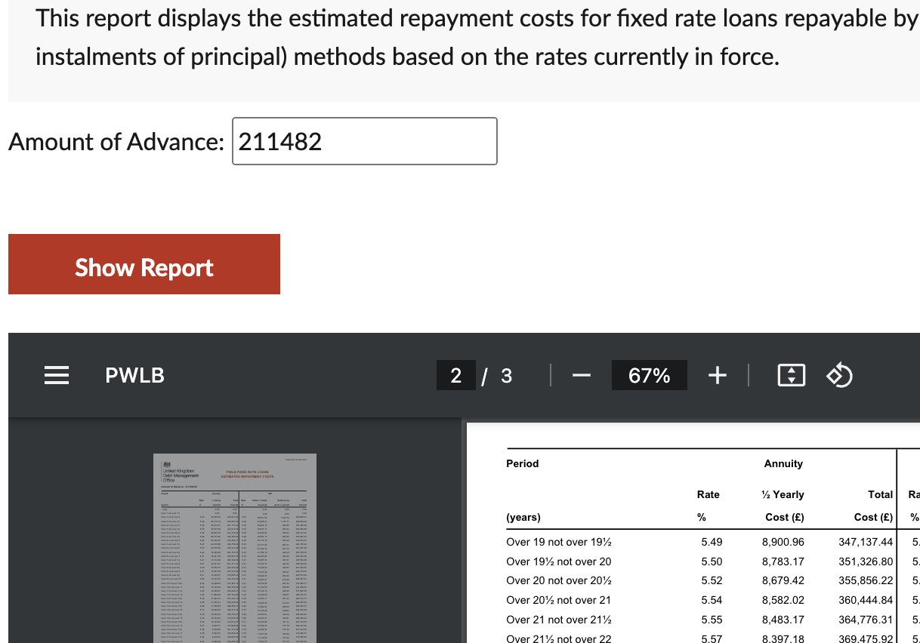

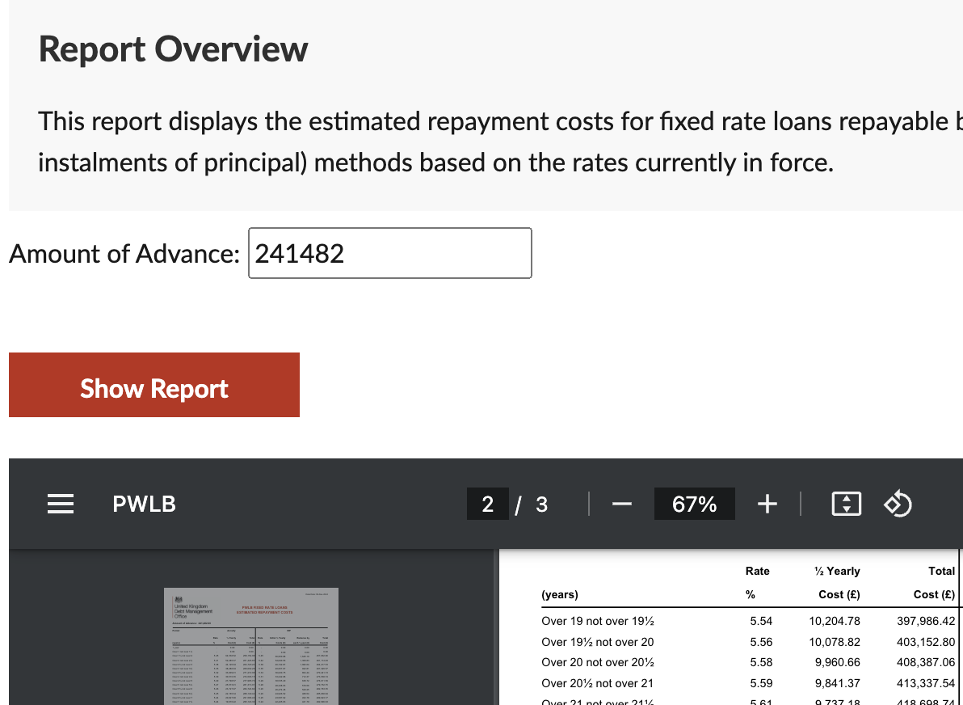

OPEX

 | hrs/month | assumed £/hr | annual cost
housekeeper |  |  | £0
bookings & promotion |  |  | £0
finance | 4 | £18 | £864
Tenant management | 4 | £18 | £864
 | 8 |  | £1,728

APPENDIX I
OPTION 4 CAPEX

BUDGET ESTIMATE OPTION 4  tenant renovates |  | OPTION 4  pre-occupation |  |  |  | OPTION 4  post-occupation Phase 2
 |  | Main Contractor |  | tenant |  | Main Contractor
External landscape
General tidy up of the site - cut grass, clear moss from paths, repair fencing |  |  |  | £500
New fence to separate PROW within NW and SW boundary, height and style similar to existing. Total length approx 90m. |  |  |  | £3,600
Building envelope works
remove moss growth, clear gutters and seal holes to roof (note asbestos constraints) |  | £1,500
clear and overhaul rainwater goods (note asbestos constraints) |  | £1,000
rectify displace bolt fixings to the roof sheets and caps missing |  | £1,500
perspex glazing changed for double glass glazing. |  | £2,100
Safe Access onto roof to undertake repairs |  | £7,500
repair damaged concrete post adjacent to entrance door. |  |  |  | £200
correct the roof verges that are slightly misaligned and displaced.
Provide improved ventilation to ceiling void by installation of vents within the cladding to the gable end
Provide gratings to gullies to prevent future blockages.
Complete external redecoration of previously painted surfaces |  |  |  | £1,000
Fully insulate the roof void to current standards |  | £2,000
Insulate and overclad the external walls. |  |  |  |  |  | £40,000
Security grilles fixed to windows |  | £10,000
Gas / heating system
Test gas boiler and heating system Itemize all items required |  | £600
From test results provide budget for required rectification works |  | £1,000
fix displaced radiators or pipes are re-fixed. |  |  |  | £200
Form cupboard around boiler |  |  |  | £100
Provide thermostatic radiator valves to radiators throughout the property. |  |  |  | £500
Paint radiators |  |  |  | £100
remove gas boiler and replace with radiant heaters/panel heaters
Electrical system
Test all electrical systems and installations including fixed wiring installation - |  | £1,000
From test results provide budget for required rectification works |  | £5,000
Test and repair emergency lighting system |  | £5,000
Replace cracked fused spur in female WC |  | £150
lockable housing to electricity and gas intakes and meters |  | £500
mechanical extraction to WC’s and kitchen |  | £2,000
improve lighting levels in access corridor |  | £750
New lighting in the hall |  | £15,000
Install solar PV panels with battery storage
Plumbing, Water services and drainage system
Test water supply system |  | £1,500
Undertake a CCTV Drainage Survey |  | £1,800
Check for soakaway or discharge of the surface water to the mains drainage.
From testing itemize and provide estimate for required rectification works
make internal and external main stop cocks readily accessible and in good condition |  | £1,200
 |  | £0
Replace cover to drainage inspection chamber. |  | £500
Install air admittance valve to soil and vent pipe which terminates in roof void. |  | £300
Replace cracked urinal |  | £300
Provide hot water to female and male WCs |  |  |  |  |  | £1,000
Fire and life safety system
Undertake Fire Risk assessment |  | £1,200
From assessment itemize recommendations and provide budget including as necessary the following |  | £0
central mains powered fire alarm |  | £5,000
emergency lighting and fire escape signage
replacement of internal doors with fire rated doors, smoke and intumescent seals and closers. |  | £1,000
Conduct Access Audit
Access audit to consider necessity for wheelchair access and WC for potential users. |  | £1,800
Install Accessible toilet |  |  |  |  |  | £20,000
Internal Fabric and Finishes
Fill cracks to the ceiling within the female WC corresponding with diagonal cracking to the adjoining wall.
Fill cracks adjacent to the wall hatch between the Leader’s Room and the hall.
Redecorate internally |  |  |  | £5,000
Remove and replace fibre board ceiling panels (insulation covered in 2.10) |  | £15,000
ASBESTOS
Update the register of asbestos |  | £2,000
Prepare management plan of Asbestos containing materials (ACM).
Remove the displaced fibre board panels to the ceiling and replace with plasterboard or similar. With reference to the Asbestos Survey, the paper lining to fibre boarding contains asbestos.
Garage
Demolish garage |  | £5,000
remove and dispose asbestos |  | £3,000
SUBTOTAL WORKS excluding roof replacement option
remove roof and replace with insulated profiled metal sheeting |  |  |  |  |  | £70,000
Compliance matters
CDM /Building Safety Act |  | £1,500
Refurbishment & Demolition pre-constuction survey |  | £750
Building Regulations Application & admin |  | £2,200
Planning Application |  | £1,800
SUBTOTAL WORKS | £0 | £102,450 |  |  |  | £131,000
Contractor's Preliminaries |  | £15,368 |  |  |  | £19,650
SUBTOTAL including prelims | £0 | £117,818 |  |  |  | £150,650
Total with assumed trade discount offers |  | £88,363 |  |  |  | £112,988
Professional fees and expenses |  | £8,836 |  |  |  | £11,299
VAT |  | £25,331 |  |  |  | £24,857
TOTAL PROJECT ESTIMATE |  | £122,530 |  | £11,200 |  | £149,144

